Living Well with Our Differences

2nd February – 16th March
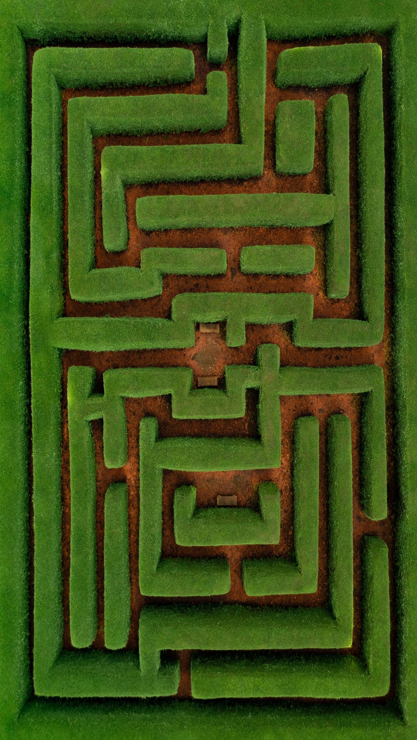https://www.pexels.com/photo/photo-of-stream-during-daytime-3225517/
Living with Autism Spectrum Disorder can make you feel as if you are different to everyone else, but why do you need to be? This Social Group was created by someone living with ASD for autistic adults and those who care for someone with ASD to socialise and discuss their diagnosis in a safe space. The workshops will focus on understanding and living with ASD. Group members will be invited to nominate topics for discussion.
In these workshops we will discuss the ups and downs of having ASD, how we cope with our condition and help build upon the social skills you don’t even realise you have.

We will look at:
Coping with social situations
Anxiety
Depression
Self Care

6 Weekly Sessions
13:00-14:00
Starts Wednesday 2nd February
Reading Central Library
13:00 – 14:00
Enrol with us, free to join

