Creative Art, Creative Communities Wilding Hearts and Healing:

February 2nd - March 30th
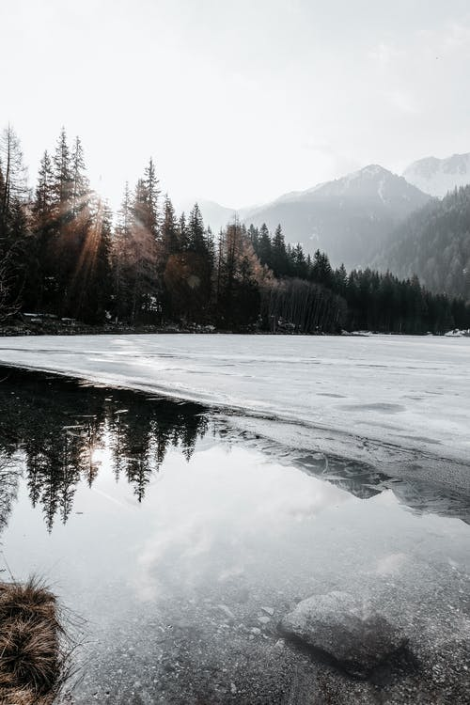
Fun and experimental workshops which are open to everyone - from complete beginners to practicing creatives.

Led by arts facilitator Lisa-Marie Gibbs, this series will explore the themes and collections of The Museum of English Rural
Life and use them as inspiration for creative responses.

The programme will give opportunities to explore drawing, painting, collage, arts appreciation and much more and celebrate the power of the arts and heritage for healing and wellbeing.

Starts February 2nd
9 weekly sessions
MERL, 14.00 - 16.00
Enrol with us, free to join

